
CHATGPT AND THE FUTURE OF COMPUTER PROGRAMMING

Warm up
1

Watch the video and discuss the questions below.

- What professionals were shown talking about AI?
- Do they think AI can replace them? Why (not)?
- How well do you think AI can do your job?



Vocabulary 1
2

Replace the underlined parts of the sentences with the correct form of the words and phrases in the box. You might also have to add words and change their order. Then discuss in pairs if you agree with the sentences.

collate (v) | exponentially (adv) | compelling (adj) | hail (v)
malicious (adj) | mind-boggling (adj) | mundane (adj) | staggering (adj)

- The amount of information that computers can process is very diﬃcult to imagine.

- The study of AI rights and ethics is a very interesting and exciting topic.

- There is a substantial risk that AI is used for bad or harmful purposes.

- Computing power will continue to increase faster and faster.

- The rate at which AI is developing is shocking.

- AI is very good at ordinary tasks but will never be able to do something truly creative.

- The potential of ChatGPT is being described as revolutionary, and for good reason.

- Programs like ChatGPT don’t actually produce anything original – they’re just good at gathering existing information from the internet.

Reading 1
3

Read the article on ChatGPT and programmers. In what order are these topics mentioned?
The author’s verdict on the impact of ChatGPT on the work of programmers.

A risk in using ChatGPT in programming.

Pros and cons of ChatGPT in general.

How programmers are likely to work with ChatGPT in the future.

What ChatGPT can currently not do well.

What ChatGPT is.

What ChatGPT will be able to do for programmers.

Can ChatGPT take programmers’ jobs?

The future of AI generators

If you use a computer to access the internet, you will undoubtedly have heard of ChatGPT - the AI program that provides original answers to virtually any request. Its potential is practically unlimited, with experts hailing its capacity to conduct medical research, design products and fight issues like global warming. An inevitable downside, however, is that it will also disrupt the job market significantly, some fields more than others. One of the jobs that, one way or the other, will be deeply affected by this tool is the very one that helped create it: computer programmers.
In the near future, ChatGPT will have evolved to a point where it can effectively assist programmers with automated tasks like bug fixing and documentation. It can also generate new code that is similar to existing code, as its ‘original’ content is actually obtained by collating mind-boggling amounts of data it has scraped from the internet.
What its current version seems to struggle with – and might always do so – is innovating, and finding new solutions to existing problems. And that’s where human programmers have more opportunity to shine now: by automating mundane tasks, they can free up time and effort to dedicate to creative aspects of their job.
That’s not to say that programmers don’t need to step up to the challenge: as AI develops at a staggering speed and is able to produce better and better code, they will need to be increasingly able to work with it, monitoring and assembling the code ChatGPT produces into functional products.
As ChatGPT capability builds up rapidly, there’s another grave problem that is emerging: to the same extent it can assist programmers to be more productive, it has the potential to increase cyber threats exponentially. The program can copy bad practices it sees online, as well as overlook vulnerabilities that leave the door open to malware. As a result, companies that turn to ChatGPT for cheap IT solutions may risk losing a lot more by exposing themselves to ransomware and other online threats.
The bottom line for programmers seems to be that, while it will indeed be taking over a number of tasks within programming, it will make the work of those who remain in the market faster and more compelling. It is also likely to create other jobs within programming, especially related to perfecting the use of this incredibly powerful tool and keeping its code safe from malicious use.
Sources: bbc.co.uk, forbes.com, businessinsider.com

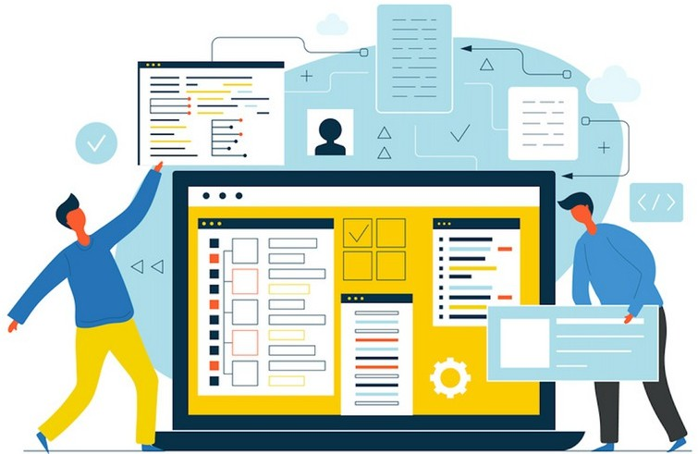

Reading 2
4

Read the article again and decide if the following sentences are true (T), false (F) or not given in the text (NG).

- The writer believes that the loss of jobs due to AI advancements cannot be avoided.

- They also believe that computer programming will be the profession most deeply affected by ChatGPT.

- The writer questions the originality of AI-generated code.

- The writer is certain ChatGPT will eventually be truly creative.

- The writer suggests programmers need to become more familiar with ChatGPT to remain relevant.

- The writer claims ChatGPT can make computer systems more vulnerable, but can also be used to increase security.

- The writer’s view of the impact of ChatGPT on the work of programmers is pessimistic overall.



Read the Grammar Box and complete the sentences with the correct form of the verbs in brackets.

Grammar box: Future perfect and future continuous
We use the future perfect (will + have + past participle) to talk about an action that will start
and finish before a certain point in the future.

In the near future, ChatGPT will have evolved to a point where it can eﬀectively assist programmers...
We use the future continuous (will + be + ing form) to talk about an action that will be in progress at a certain point in the future.
The bottom line for programmers seems to be that, while it will indeed be taking over a number of tasks within programming,...

- AI evolved enough to replace me until I retire. (not become)
- ChatGPT to assist you in your work in the near future? (you / use)
- In about five years, AI automatic tasks in most areas. (perform)
- At the end of the year, people so much about AI and the job market. (not talk)
- Many professionals replaced by ChatGPT by the end of the decade. (be)
- By the time AI starts really disrupting the job market, other types of jobs . (appear)
- In a few years’ time, most professionals with some form of AI. (work)
- What by the end of the decade? (ChatGPT / achieve)

- With AI doing most mundane tasks, we just creative work soon. (do)

In pairs, roleplay the following situation.
Student A
- You are a partner in an IT company.
- You are thinking of replacing some of the programmers with ChatGPT.
- Discuss the situation with your business partner.

Student B
- You are a partner in an IT company.
- Your partner is thinking of replacing some of the programmers with ChatGPT, but you are wary of the risks.
- Discuss the situation with your business partner.

Talking point
7

In small groups, discuss the questions below.

- Is ChatGPT truly improving the work of programmers? What about other jobs?

- Can AI become a threat to the very existence of humankind? In what way?

- Should AI have rights?

- What jobs do you think will never be replaced by ChatGPT and other AI tools?

- Will AI help humans to become smarter, or the opposite?

Complete the extract from the Warmer with one word in each gap. Then listen again and check.

I’m a software engineer. ¹ I work, we’re always trying to know: where can I find the best craft beer? Please generate the code ² a website using HTML CSS and Flask that tells me where there’s craft beer near me. This is just raw code. You actually need to run the code ³. I’m copying and pasting the code into separate files and it generates a website. How cool! Here’s our website. All three pieces: the back end, the front end and the styling ⁴ actually make something that was human readable. That generates a
website that we can look at and understand ⁵ it does. It ⁶ seem like a huge feat to me.
I’m a doctor. This prompt is ⁷ that a patient might enter: I have a fever rash and body aches. The rash looks ⁸ small welts on my genitals. Do I have monkeypox? The response is pretty solid in the ⁹ that it’s unlikely that you have monkeypox. The specific thing it ¹⁰ right was that the monkey pox rash is actually not prominent on the genital area. It ¹¹ on to say that a rash in the genital area most likely is an STI. The rest of the answer is just ﬂuff: talking to your healthcare provider,
¹² is pretty obvious. Can AI do my job? I don’t think it’s there yet. I think the AI right ¹³ is really good for a first-year medical student.

